A Quick Update

Most of you know I have committed my next two years to the Youth With A Mission (YWAM) Vancouver staff after finishing my Discipleship Training School (DTS) there earlier this year. It is a daunting but exciting step for me; I will be volunteering at the base in Canada and relying on God to provide for me. I plan to move into my new home on November 1st! Here is a little of what God has been doing in my life since my last newsletter.

## Tygh Valley

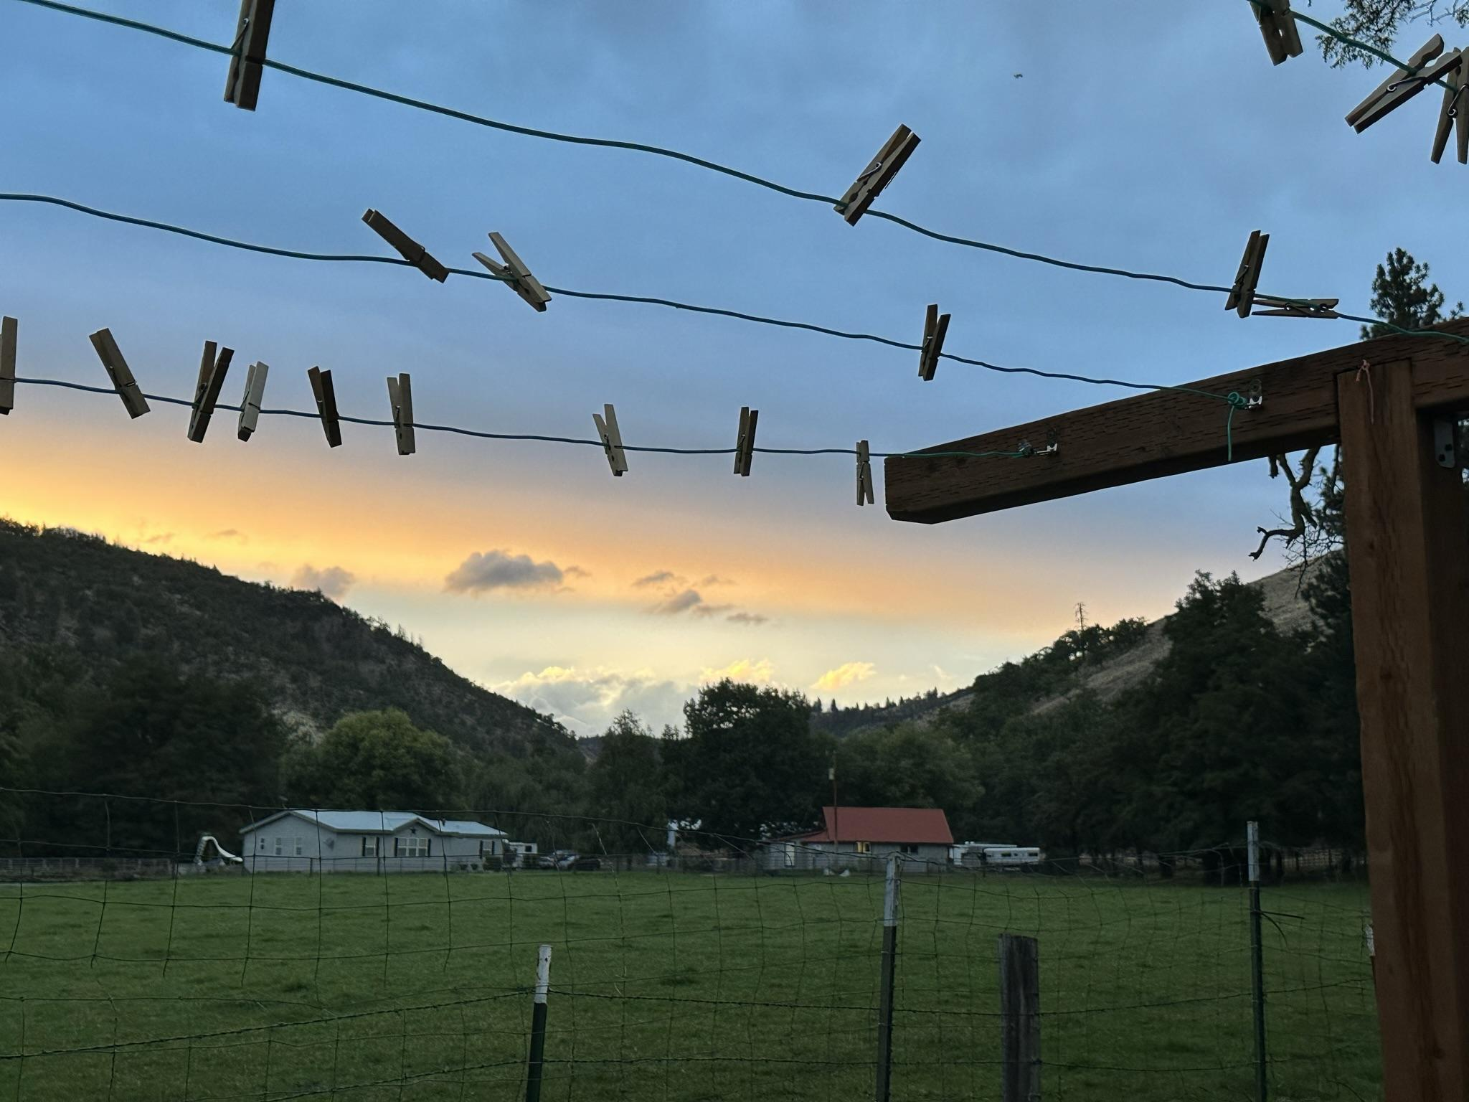

At the end of my DTS, I had a couple of weeks at home before my parents flew to Brazil to start their new adventure of being international Super-Spies!.. I mean international teachers. So, I spent those two weeks packing and selling all my belongings. I managed to condense all of my possessions into boxes that all fit into my car, except one which I stashed, and the only way to find it is to follow a series of treasure maps. After we cleared the house, I headed to Bill and Patricia’s property in Tygh Valley, which became my new home/work site. The first thing I did once I arrived in the Valley was go to Church. There, I was lovingly plugged into the community and found plenty of work to keep myself out of trouble. 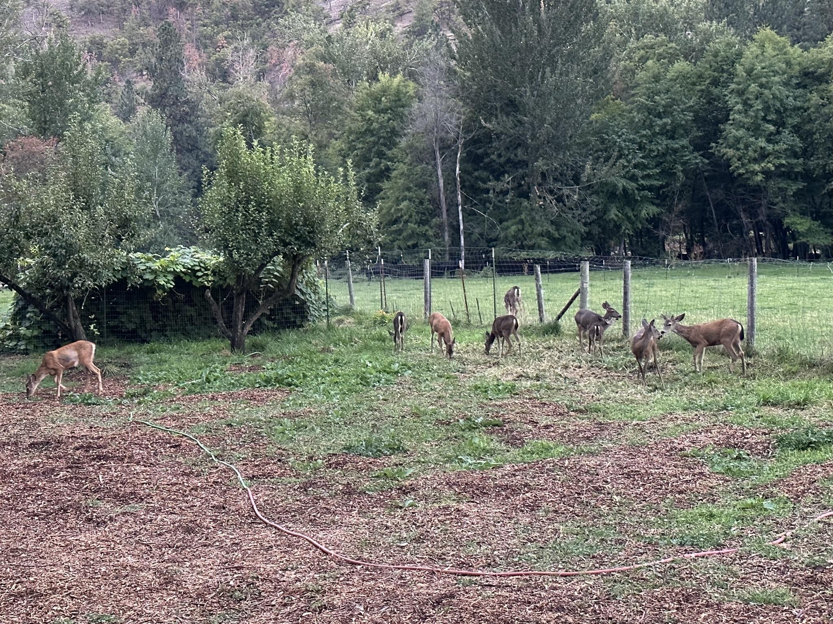

I have fallen in love with this rustic place and all the people who live in the small collection of houses, farms, and ranches. I want to thank everyone here for being so genuine and loving to me! I cannot thank you enough for welcoming me into your lives and encouraging me along my path. I have really enjoyed lending a hand where I can, spending time in this wonderful community, and being surrounded by so much wildlife!

## Wildland Fire Fighting

I had the opportunity to fight a couple of fires this season, and they were a lot of fun! Not only did I get to spend weeks in the middle of the woods with no cell service, see the power of fire first-hand, work my tail off with a team of hard workers, and play with a chainsaw, but I got to build many good relationships with my crewmates. God made it apparent to me that the people enticed to fight fires are often drawn by the ability to escape their lives outside the fire camp. Some of my friends are in hopeless and terrifying circumstances, and a few do not realize the severity of their predicament. This community needs the love of Jesus, and I hope I was able to facilitate that in some way. I am keeping in contact with many of my crew mates and working on the relationships God has provided me through this time.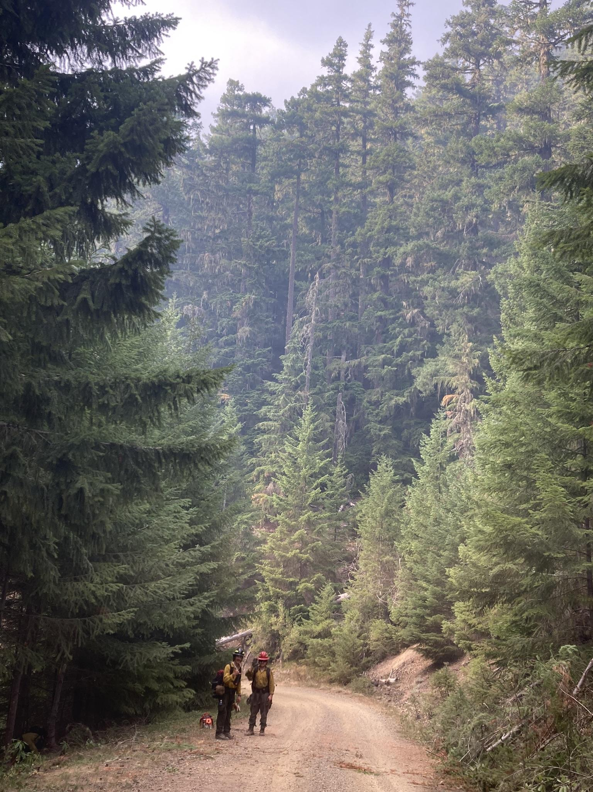

## 

## YWAM Canada Gathering

From August 14th to August 18th, I attended a gathering in Manitoba of all the YWAM bases in Canada. This was a great time to see familiar faces and to make many new friends. I had many intriguing and encouraging interactions with people who are boldly following Jesus’ direction for their lives. It was fascinating to hear some of their stories, and I was moved by many of their experiences with the mercy and love of Jesus. We also had many fun activities like a mini Olympics and a very intense table tennis tournament to help inspire relationship-building. 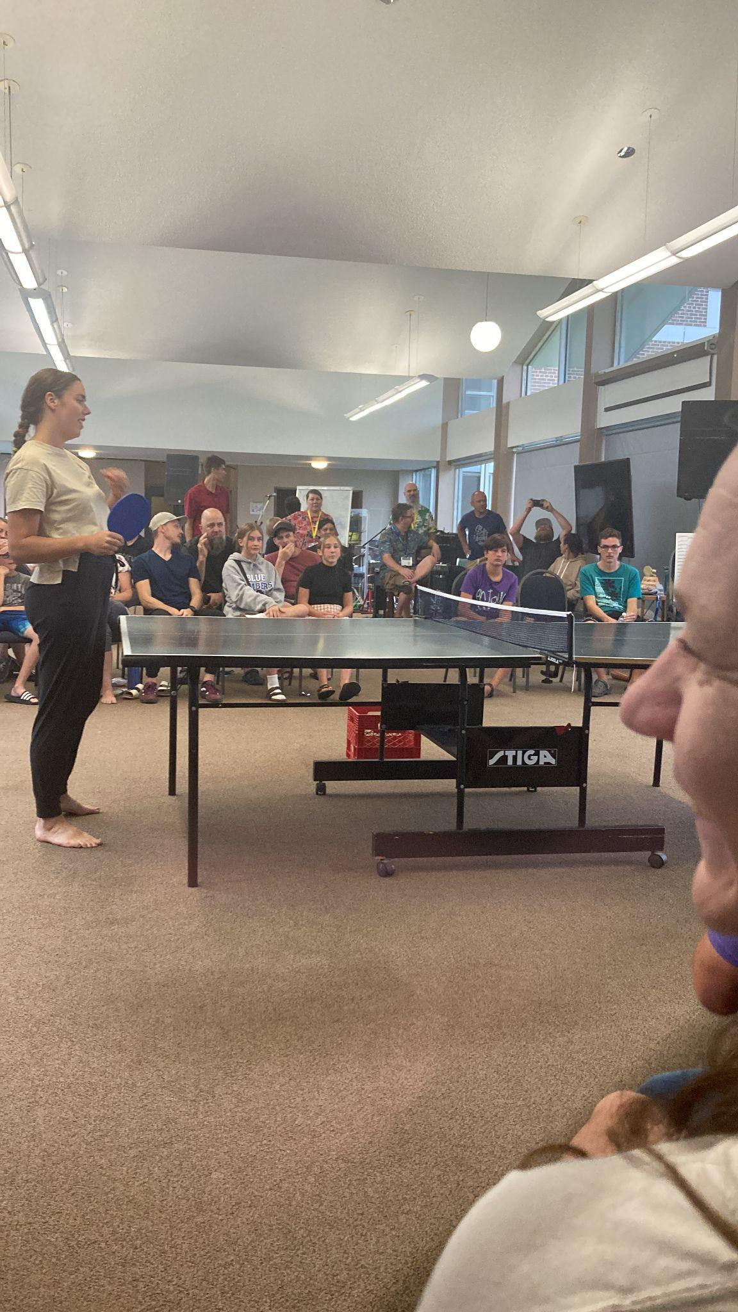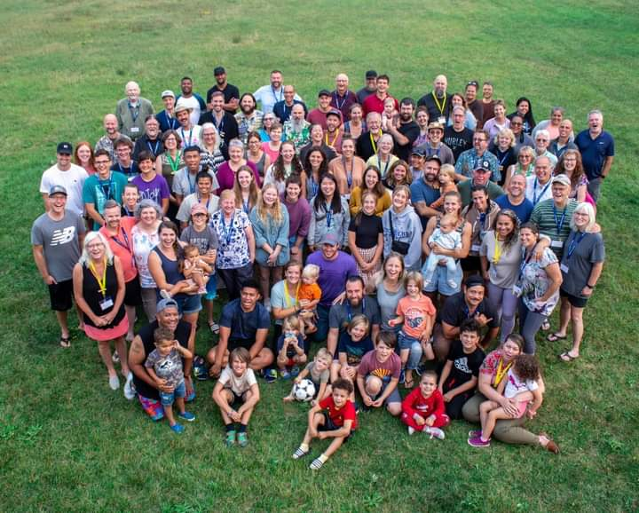

During this time, God really emphasized the need for sacrifice to me. I need to be happily willing to give it all up for Jesus. If I can’t give everything to Him, what am I really worshipping?

## Prayer Points

* As I get ready to travel to Vancouver, I would really appreciate prayers for a safe journey. I have a very old car.
* I would also like prayers for provision. When I get into Canada, I will not be able to work for money anymore, so I will be relying on support from anyone generous enough to give a dollar.
* Please also pray for my brother Josiah as he begins his career in the Coast Guard. I pray he stays safe and stays motivated. Also, pray he can be drawn closer to God.

Well, that’s about all I got this time. Once I get settled in Vancouver, I aim to write an update every month, but no promises. At the very least, I will upload pictures to my website and maybe onto Instagram and Facebook. I hope you enjoyed reading about what God has been doing in my life.

If you would like to support me while I am in Canada, check out my website or write me an email. Whether it is a one-time donation or you decide to continuously support me, I cannot thank you enough!

Thank you all for reading this. It means a lot that you are interested in how God is moving in my life. So I want to know what He is doing in yours! Let me know what you think of the update, or just say hi, but please reach out.

A special thank you to Bill and Patricia for providing me with a place to sleep, for feeding me, and for being so encouraging to me the whole way through. I love you two!

I pray that God blesses you all in everything you do and know He is with you through it all.

Ezekiel Smith.

Email: [ezekielbairdsmith@gmail.com](mailto:ezekielbairdsmith@gmail.com).

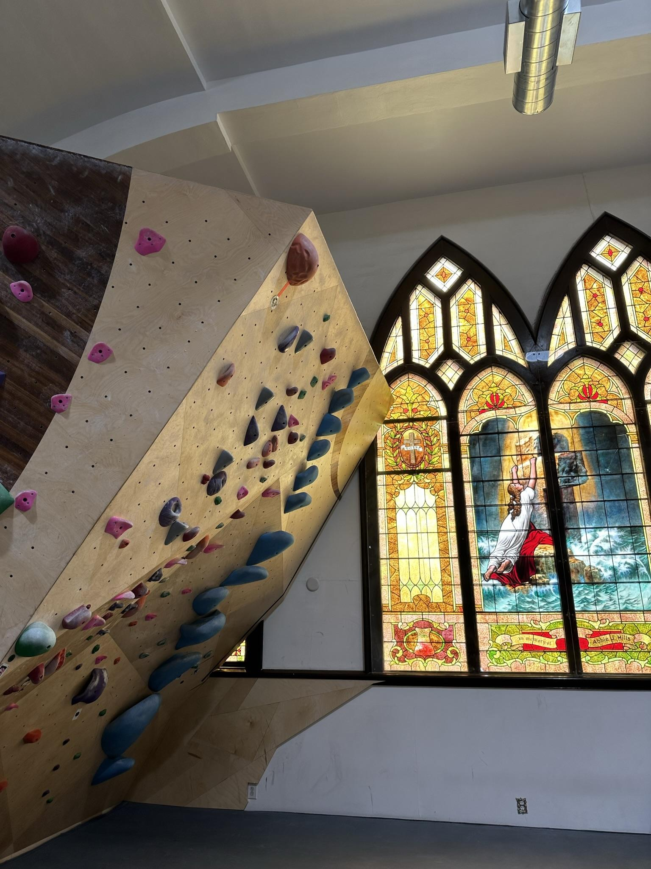Website: [WWW.smithezekiel.com](http://www.smithezekiel.com)