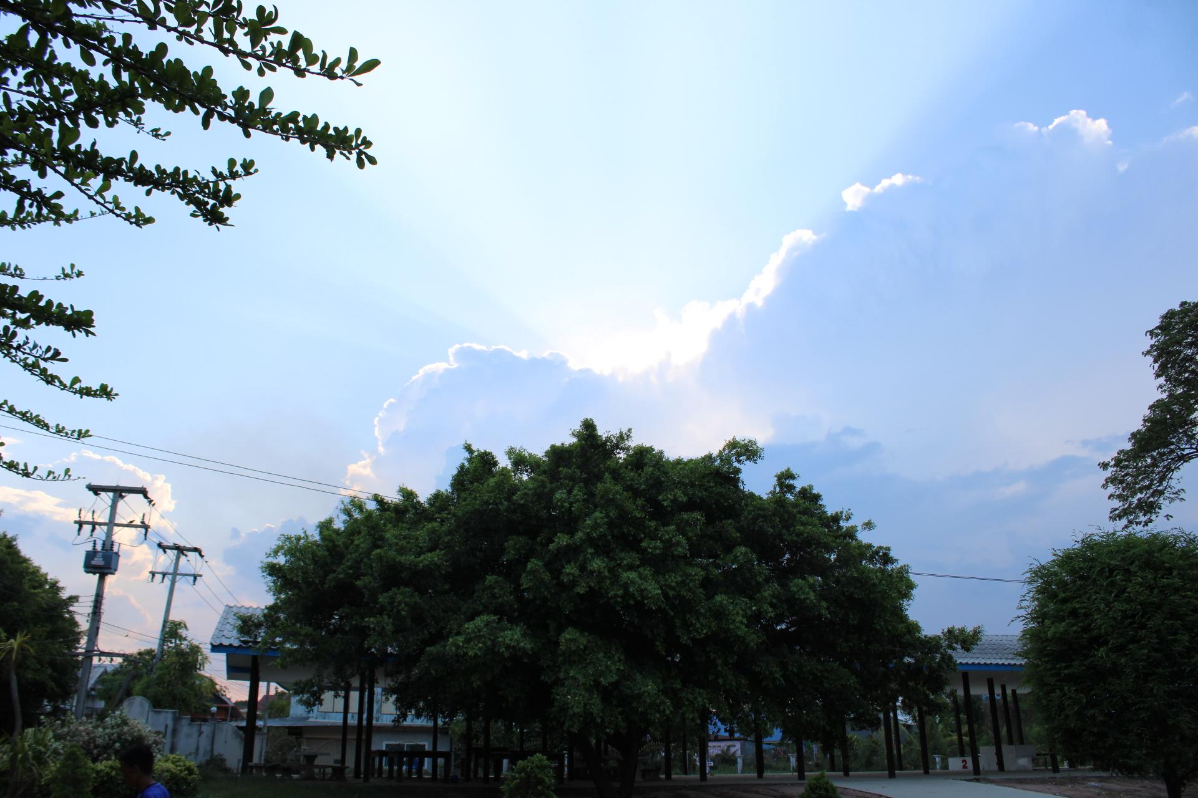

2023 DTS Newsletter

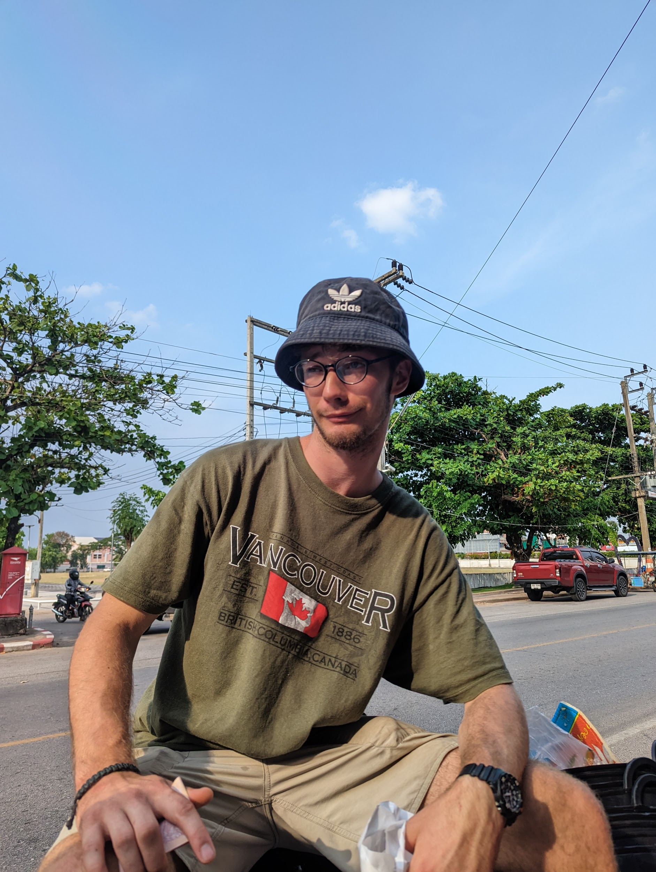
The past five months of my life have been an exciting journey filled with emotion and wonder. I completed my DTS (Discipleship Training School) in Vancouver, BC. I was baptized and traveled to Thailand with a crazy crew of Christians to do some seriously enriching ministry work. This newsletter is all about my experiences during the first part of 2023.

I came into this program with few expectations but a lot of excitement. And once I had met everyone, I was overwhelmed by the presence of God. I had never in my life felt Him so clearly as when we worshiped that first morning back in January. After this, I began, with wide eyes, to see how God has been working in my life, leading me to this point despite all my efforts to mess up His plans. Thank God for bringing me here.

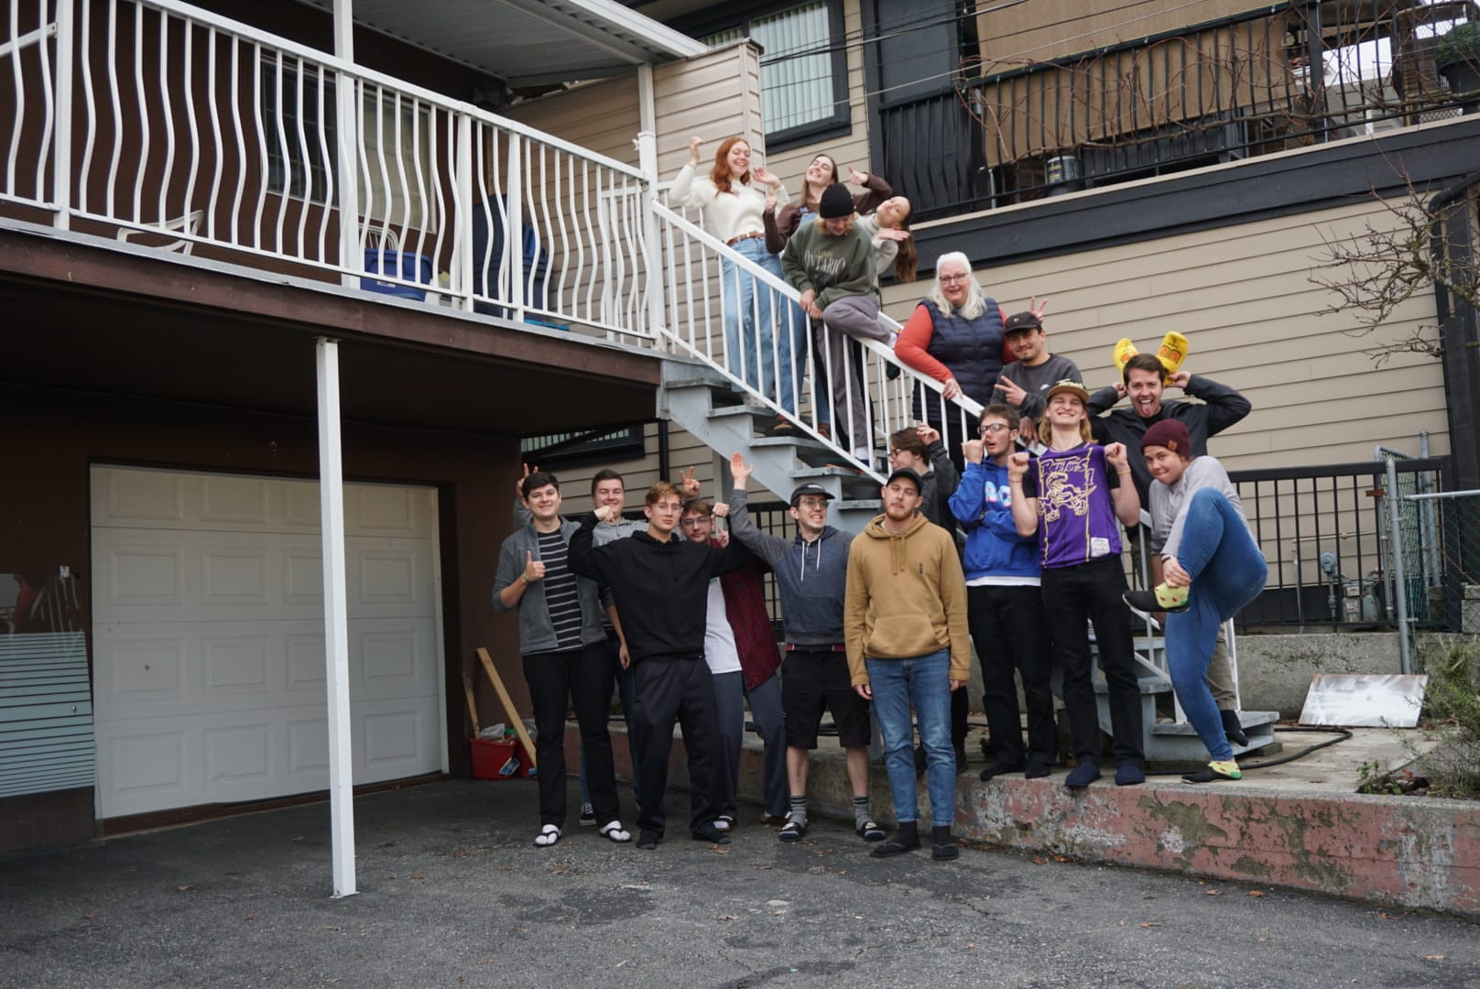
Part one: Lecture Phase
Our lecture phase was packed with wisdom and insight into who God is, who God made us to be, and our role in God’s plan. Each week we had a new speaker and a new topic. Every teacher brought their expertise to the classroom and helped us digest the content in ways we would all understand.

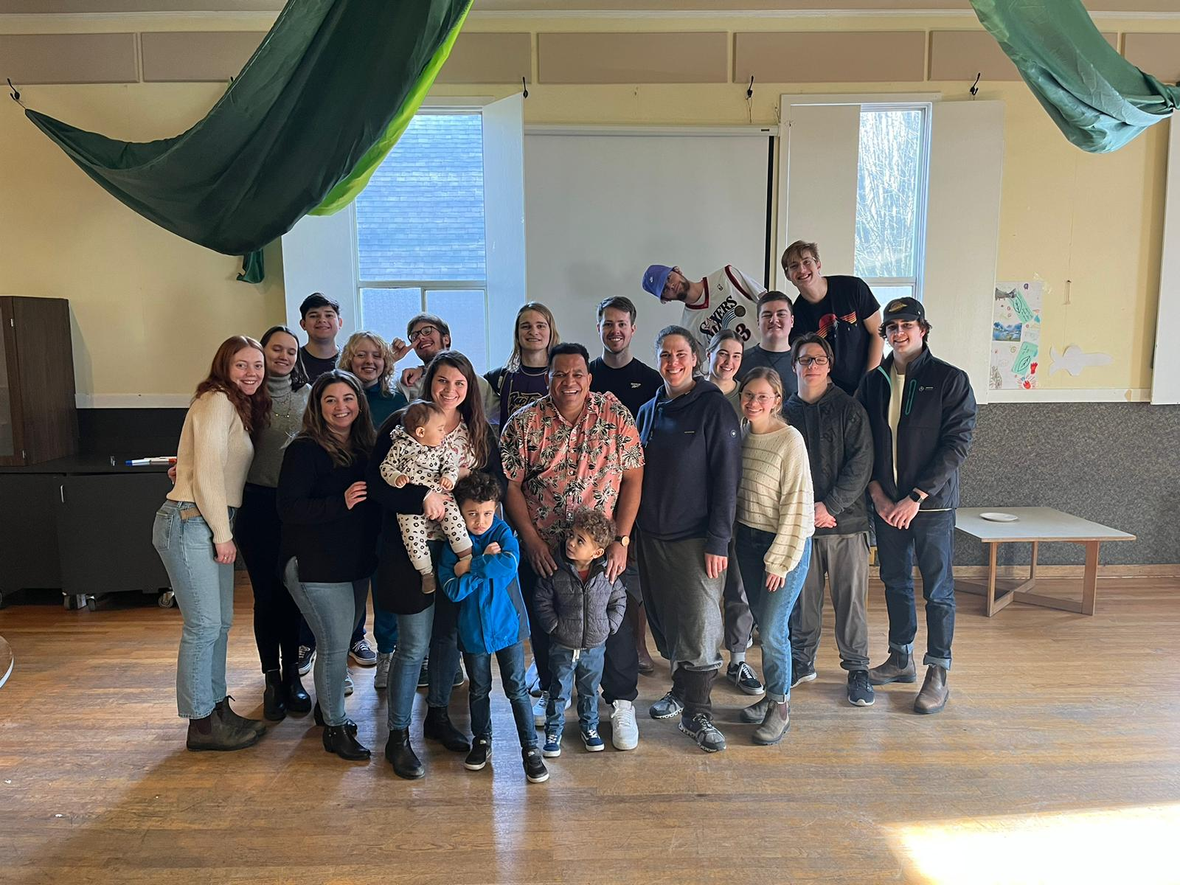
Our first week was an overview of the Bible led by Andrew Heffren, one of the staff here at YWAM Vancouver. This week was a LOT of fun! Everyone was so excited to meet each other, and the content was familiar enough that I could commit much more effort to remember everyone's names.

My favorite week was the seventh. Worship led by Billy Theunissen and his wonderful family from South Africa. He made space for the Holy Spirit to move in our classroom and let God direct his life and teaching. My key takeaway from that week is that worship is constant. Praising God is not done exclusively through singing or playing music. It is in all areas of your life. Every time you smile, you are praising God. Every time you talk to someone, you are praising God. Every time you wake up, you are praising God. He created all things. So in all things, we should be thankful! This is a hard lesson to walk out, but I am working on it.
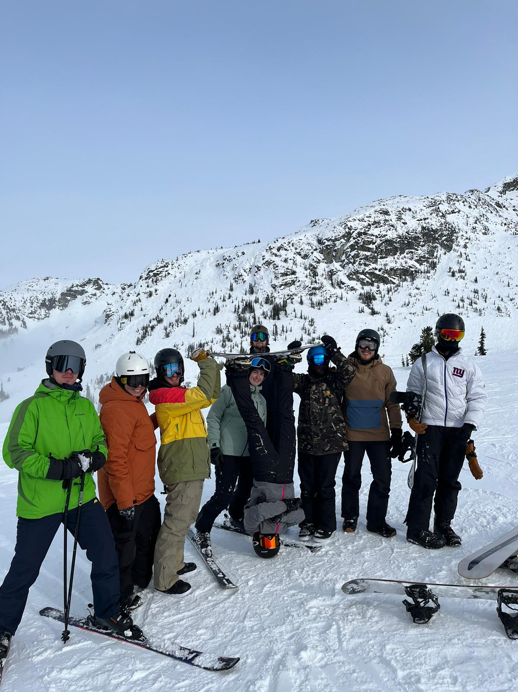
While we were learning a bunch; and having fun in the classroom, we were also having a ton of fun up on the mountain! Every Wednesday, we would head up to Mt. Seymour to shred some sweet powder; and share God’s love with our fellow shredders; this was a great way to connect with a community outside of DTS and practice what we were learning each week. We also got the privilege of riding at Whistler and Blackcomb during one of the weeks. Which, if you don’t know, is a crazy-huge resort with some majorly steep runs! I am very grateful for that opportunity.

Another experience we had during the lecture phase was heading up to Fort MacMurray in Alberta for the Arctic Winter Games. We were there for two weeks and stayed on the floor in a very hospitable church hosted by some YWAM friends of our staff. During those two weeks, we got the chance; to volunteer at the Arctic Winter Games, where we saw young athletes from all over Canada test their mettle. There was special encouragement for the Native people and their games. So we got to watch some exciting sports from their culture. It was also freezing cold up there, but that didn’t stop us from riding all over town on the buses.
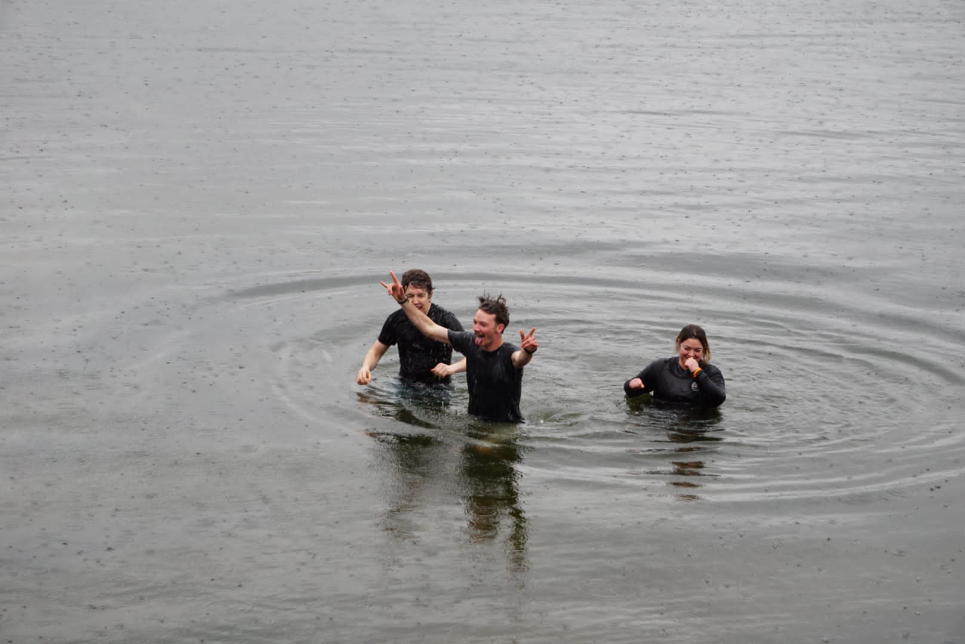
As we approached the time for us to ship out to Thailand, I was given the opportunity to get baptized alongside Andre and Maximus. It was pouring down with rain and terribly cold out but I loved it. This was a huge moment for me and I am so grateful that I was able to do it surrounded by such a wonderful group. To me, it was a commitment to pursue Jesus. Committing to things is something I often shied away from and I would often run when it got too hot. But now, I am dedicated to run towards God, not away.

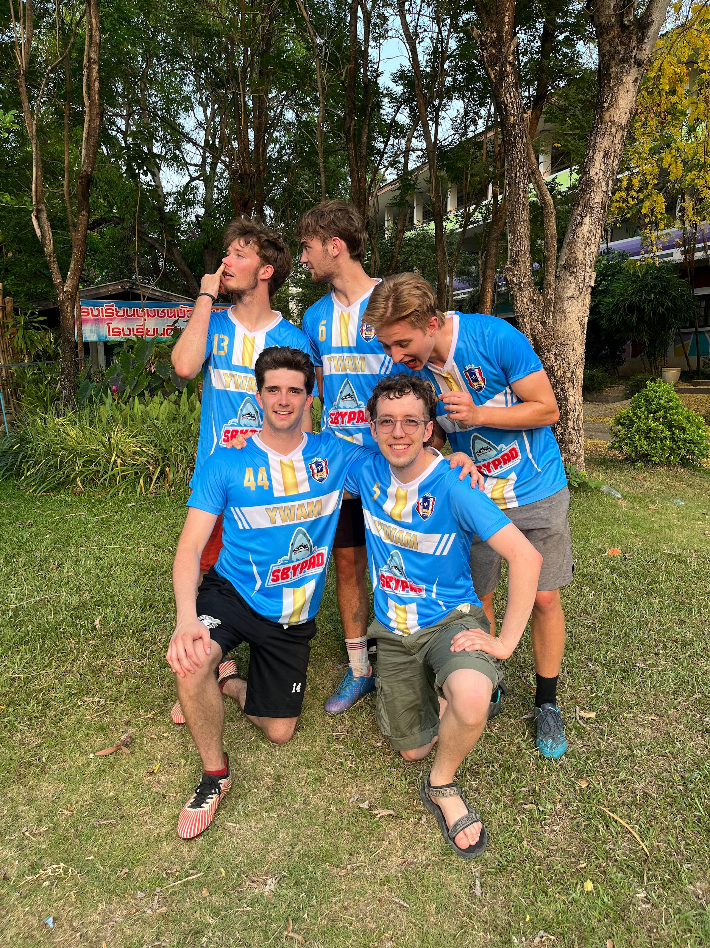
Part Two: Outreach

For Outreach: our group of 12 students split into three teams, to be accompanied by two staff on each team. My team consisted of Jonothan and Sam as our leaders and Benedict and Maximus as my student comrades. We had the least people on our squad, as we were supposed to have a student named Danny join us, but he went home early in week seven. However, being down a man didn’t hinder us from getting the work done in Thailand.

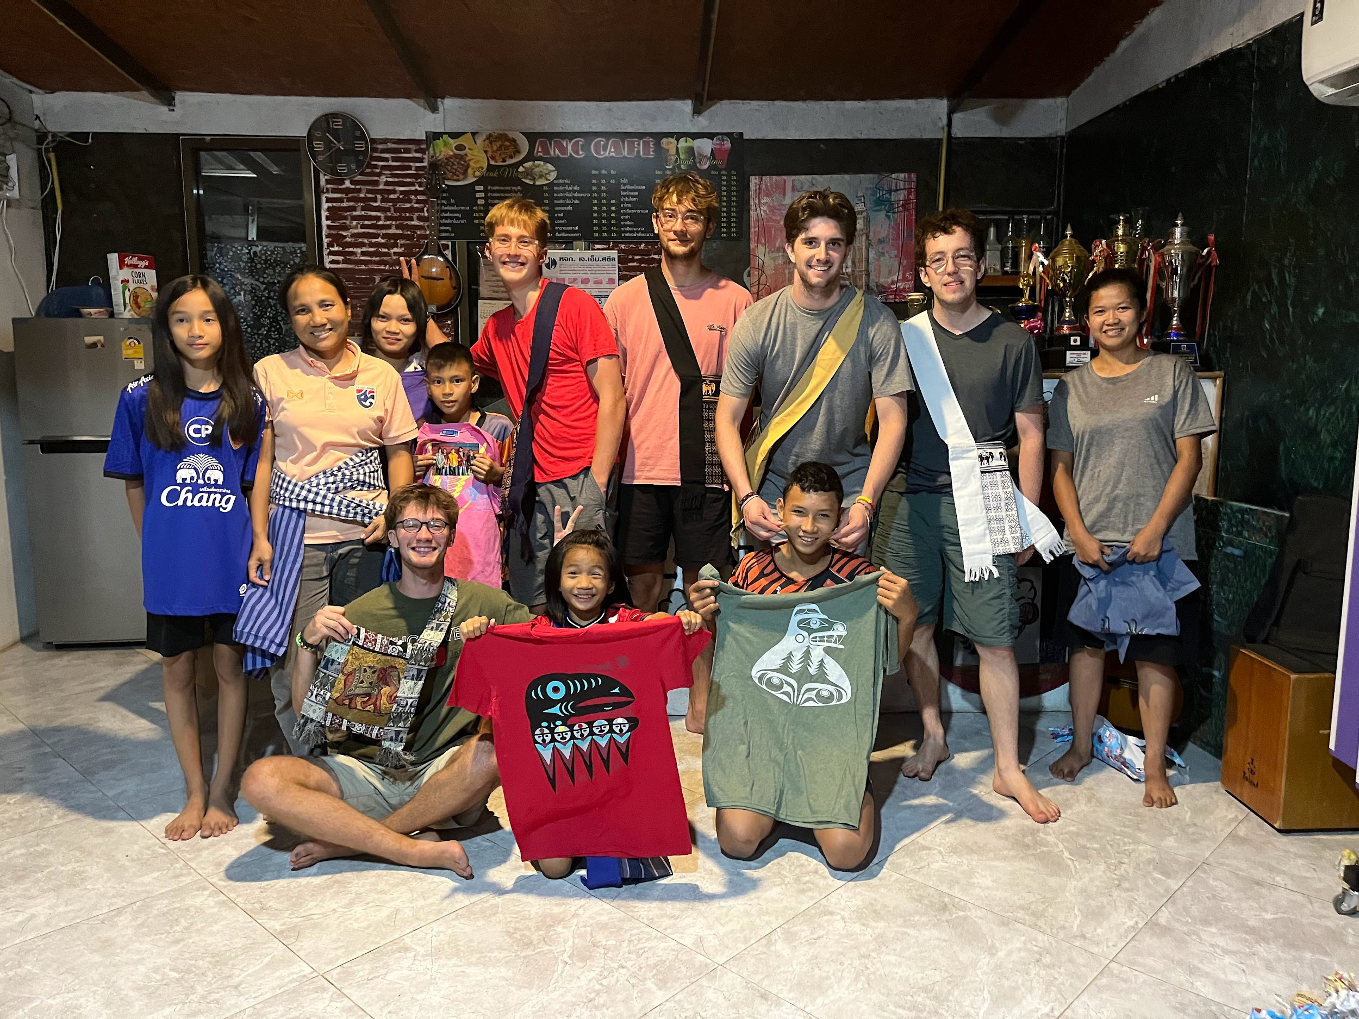
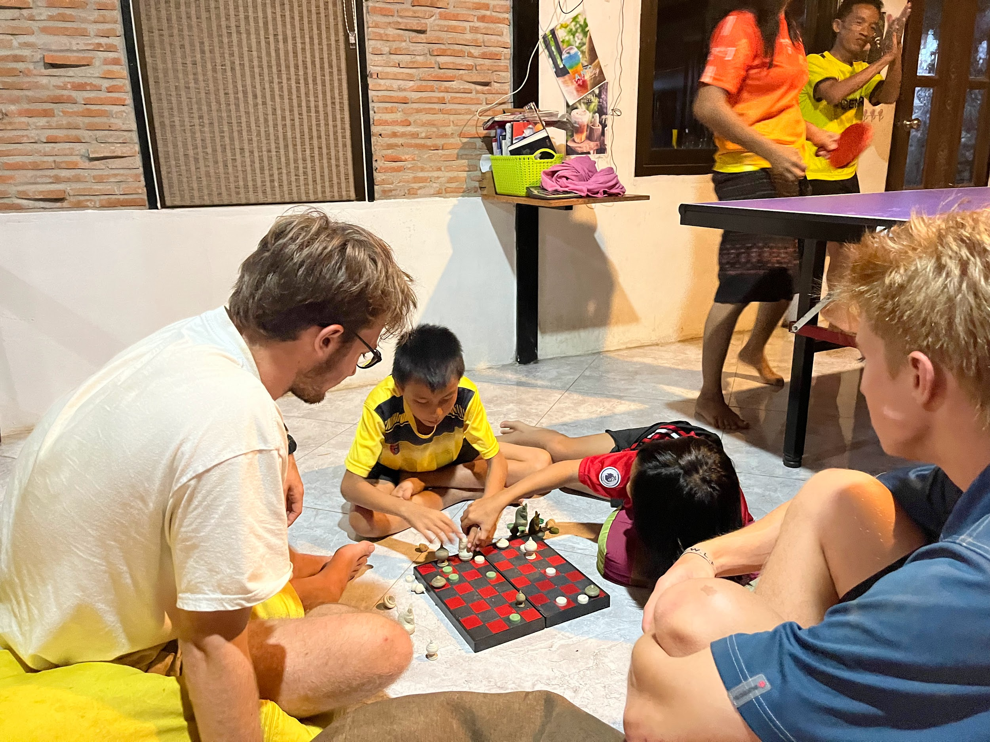
My team and I stayed with a wonderful family in Nong Bua Ban, Chaiyaphum, northeastern Thailand. Our Hosts were Naan (the father), Raem (the mother and our translator), and their six children: Thip, Paul, Naomi, Asia, Matthew, and Nation. Four of their children are adopted, and Naan is an orphan, so they all have big hearts for young children without homes. They are one of two or three Christian families in the whole village of predominantly Buddhists. Their faith has caused old friends to shut them out and turn their backs on them. After thirteen years of reckless love for their friends, they have begun to be welcomed back into the community. Their ministry was running a sweet cafe on their property, which they built by hand, for the people in the village to hang out at. They also run a football (soccer) club every evening. They make it a safe and fun space for kids to come and play instead of getting into drugs, alcohol, and sexual activities. The club is open to all ages, but the little ones play for an hour, then the big kids play until the sun goes down.
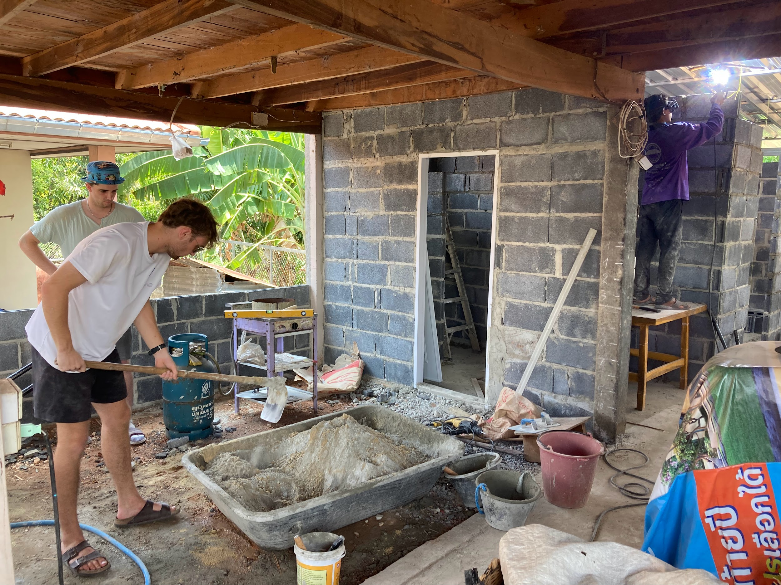
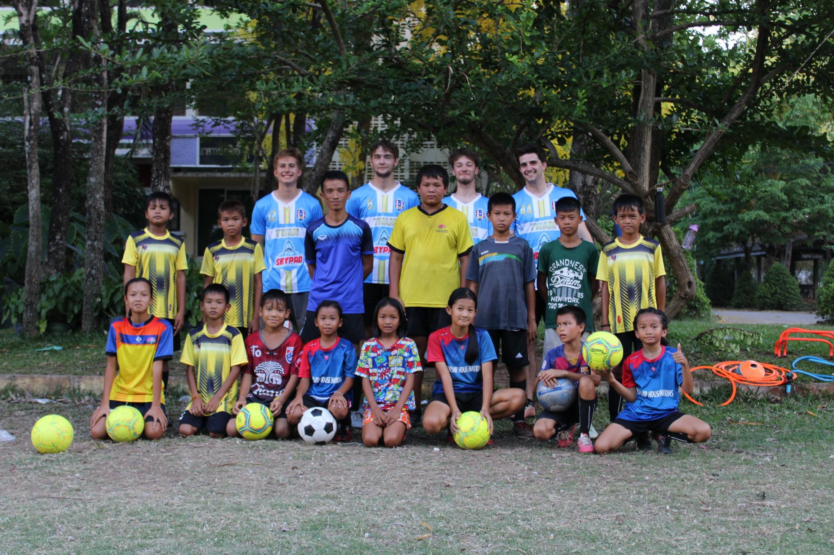
So almost every day, we stayed with them; our daily routine would be to wake up at seven and go to work doing construction, laying bricks, pouring cement, and fitting windows until lunchtime. After lunch, we would teach English to some kids from the village in the cafe. I enjoyed teaching the kids so much because they were so curious and full of energy. They were also incredibly quick learners; I could not believe how well they picked up what we were teaching them. I loved building a relationship with each of the children that would regularly come to see us. After teaching English, we would head off to play football for the rest of the day. Then rinse and repeat.

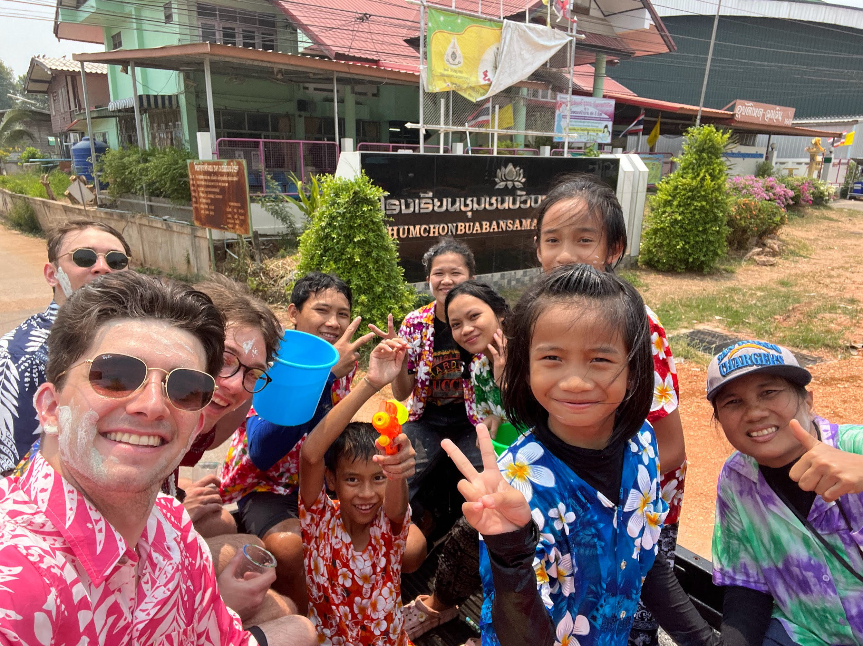
During our stay in Thailand, we celebrated their new year. It was unlike any new year party I had ever been to. It is a three-day party, in some places a whole week. We would all load up into the back of the pickup with a gigantic bucket of ice water and start driving around the town, chucking the water on anyone who crossed our path. It was a country-wide water fight! People would also walk by and paint your face with some strange-smelling, colorful powder, which was a little odd, and I can’t say I ever got comfortable with it over the three days. Overall, it was a super fun but cold time, and the kids loved it!

During the last week of our stay, we got the privilege to go to ALLC. Which was a leadership conference for YWAM staff members from all over Asia. This opportunity was huge for our team as we got to; meet some incredibly interesting people, hear some of the wildest stories of faith, and make many new friends. I can’t count how many countries were being represented there; some people had come from as far as Pakistan just for this week-long gathering.

Thank You!

Sorry, that was a lot of words! There are so many more stories I could’ve included, but I didn’t want to write a book about it all, and I’m not sure some of you would want to read all that, let alone all this. Anyway, I could not have experienced this without all of you. I am so thankful for everyone who has helped me grow into the person I am today. God bless you all! I am praying for you!

God has decided that I will continue my journey with YWAM. So I have applied to join the staff in Vancouver this coming fall. I would greatly appreciate any prayers or support you are willing to offer. I am setting up a way to make donating easier, and I will be writing newsletters more regularly once I am on staff. Don’t worry; they will all be a lot shorter than this one.

Also, don’t be afraid to reach out if you want to hear more stories or have any questions. My email is ezekielbairdsmith@gmail.com and my number is +1 541 645 4835.

Once again, thank you all, and God bless you!

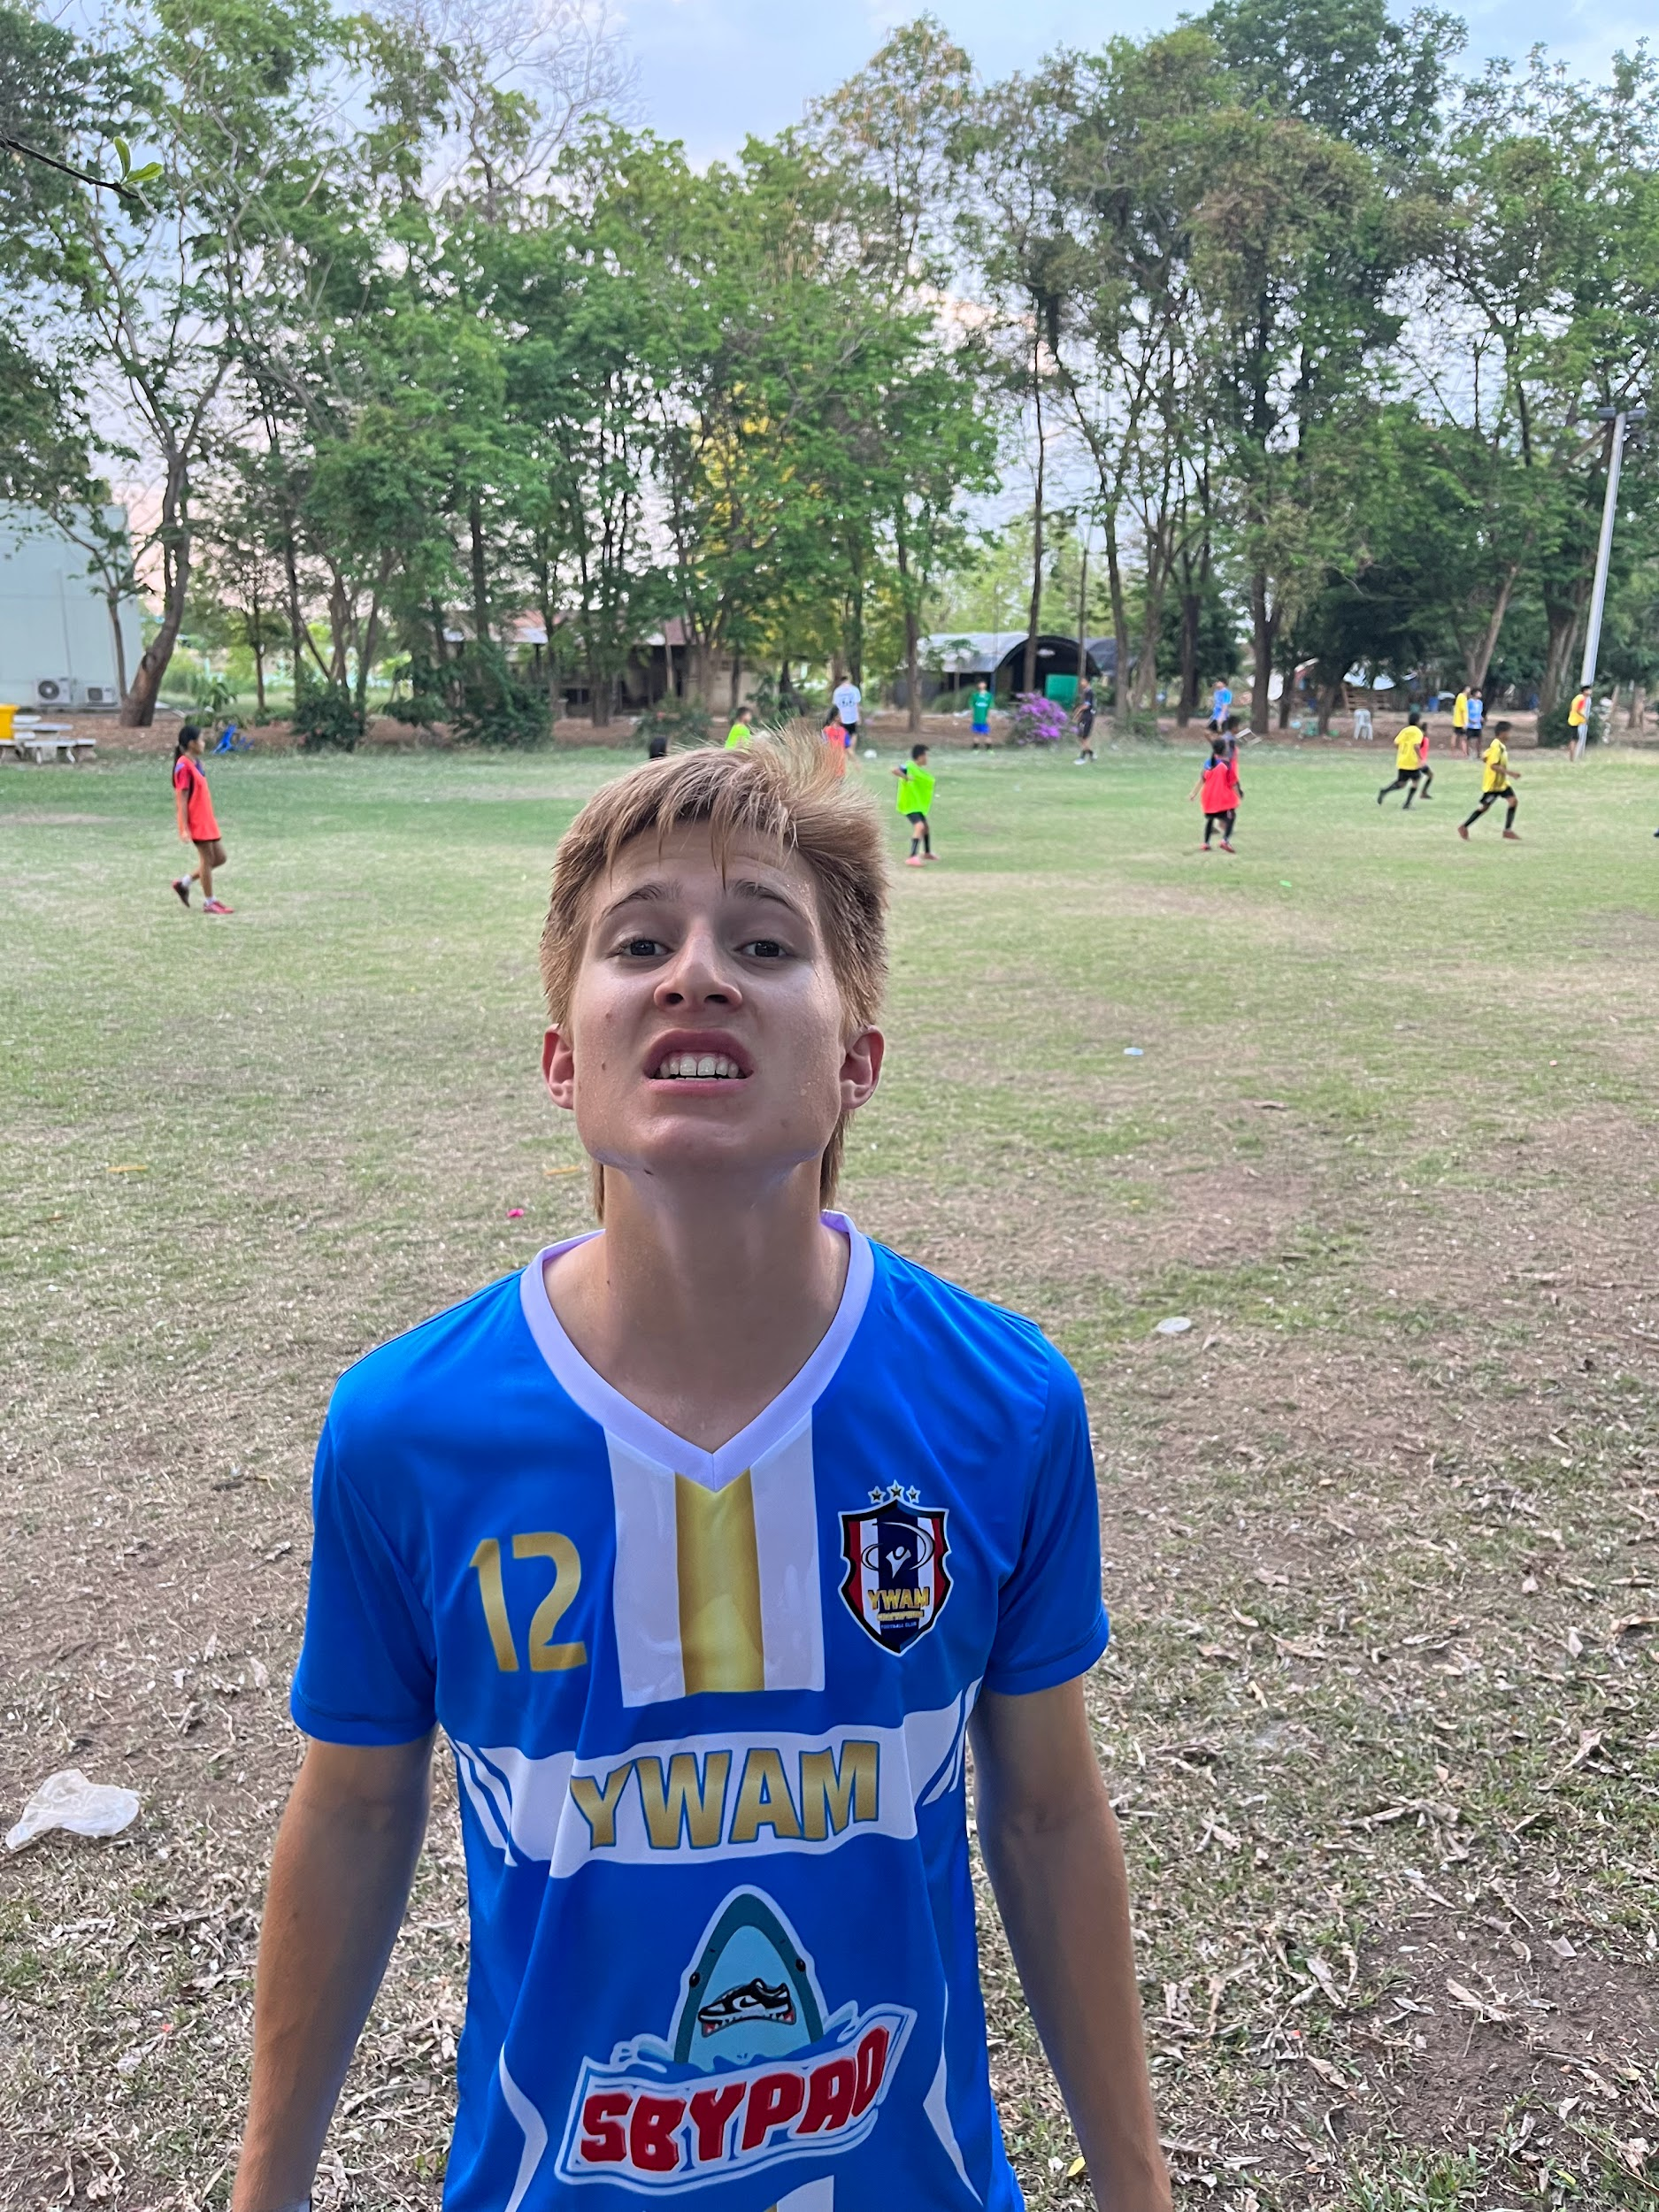
Ezekiel Smith.

